Tim Bell
ENGR 12L
June 5, 2014
Audio Mixer

For my final project I decided to build an audio mixer based off of the op-amp lab we practiced in class. The idea is to have two separate audio signals combined into one and share a speaker. This way I can have two songs from two different audio devices (iPod, laptop, phone, etc.) and play them on the same speaker at the same time, each with its own volume control. This is the basic idea for professional deejays and how they mix sounds which I thought was a cool idea.
The circuit I built was very simple and actually does not involve too many pieces. The material I needed include:
- 8 pin LM741 op-amp
- 10 kOhm resistor
- Piezo electric speaker
- (2) R502 potentiometers
- (2) 3.5mm audio jacks
- Power supply of +12V and -12V
The circuit starts with two separate audio devices the directly connect to two separate potentiometers. The potentiometers control the gain of the signals and therefor the volume of each audio device. Both potentiometers connect into the same wire going into the V- terminal of the op-amp. The V+ of the op-amp goes to ground and there is a 10 kOhm feedback resistor from the V- terminal to the output terminal of the op-amp. Of course there is a +12V and -12V power supply going through the op-amp. Finally there is a speaker connecting from the output of the op-amp to ground from which both audio signals are coming from. As you adjust the potentiometers the volume of the corresponding audio signal will adjust so you can mix sounds to your liking. Basically the circuit is a summing inverting op-amp and this is what it looks like in schematic form:
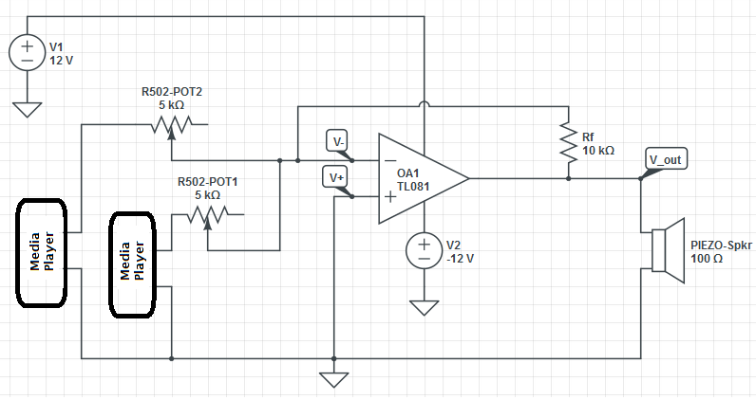

The actual circuit (minus the power supply) looks like this:
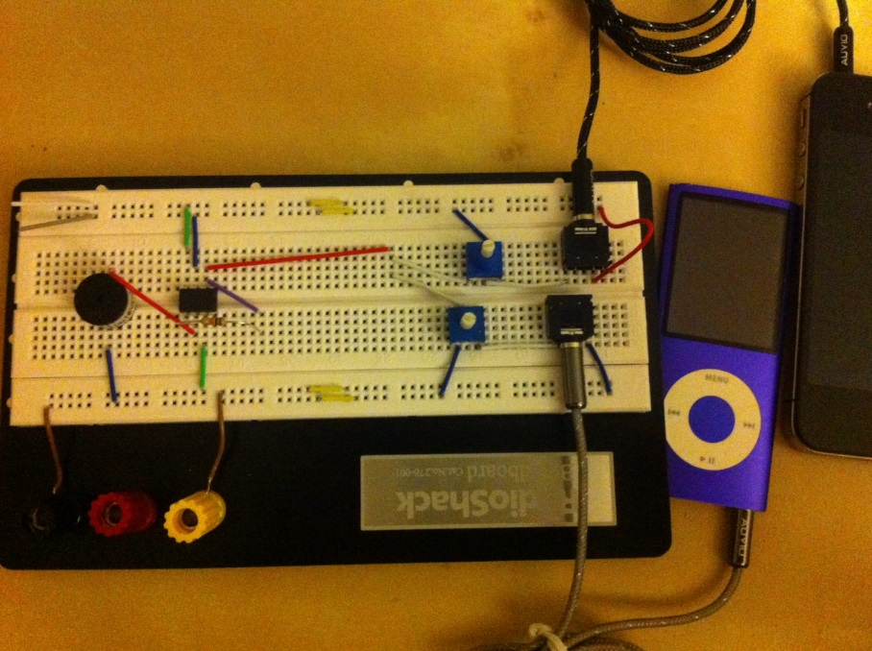

Close up of audio jacks and potentiometer:

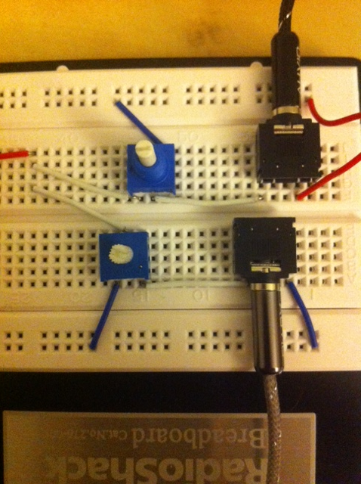

Close up of op-amp, resistor and speaker:

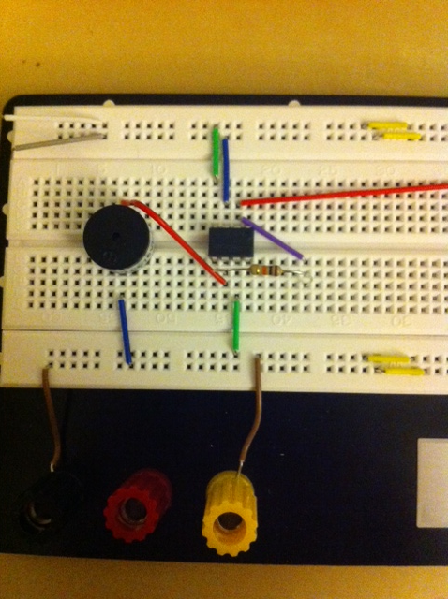

This final project was fun to build. It was not too difficult but still took a decent amount of effort and time to complete. This project helped me obtain a deeper understanding of how op-amps work. It was helpful with using a real op-amp as opposed to just looking at a schematic or a picture of a triangle. Now I can see how op-amps can be applied in real life scenarios.

